What is Amazon CloudFront?
Amazon CloudFront is a Content Delivery Network (CDN) service that securely delivers data, videos, applications, and APIs to users globally with low latency and high transfer speeds. It caches content at AWS Edge Locations to improve performance and reduce the load on the origin server.

📍 How CloudFront Works?
1️User Requests Content → A user requests content from a website using a CloudFront URL or a CNAME (custom domain).
2️Edge Location Checks Cache → CloudFront checks if the content is already cached in the nearest Edge Location.
- ✅ If Cached → The content is delivered immediately with low latency.
- ❌ If Not Cached → CloudFront fetches the content from the origin server and caches it for future requests.
3️Response Delivered → The user receives the requested content quickly and efficiently.

📍 CloudFront Key Features & Benefits
Feature |  |  | Description
Global Edge Locations 🌎 |  |  | CloudFront has 400+ Edge Locations worldwide to cache content closer to users.
Reduced Latency & High Speed ⚡ |  |  | Content is delivered faster by serving from the nearest Edge Location.
Origin Support 🖥 |  |  | Supports S3, EC2, Elastic Load Balancer (ELB), or custom origin servers.
DDoS Protection 🛡 |  |  | Integrated with AWS Shield to protect against attacks.
Security & Encryption 🔒 |  |  | Supports HTTPS, signed URLs, signed cookies, and IAM policies for access control.
Cost-Effective 💰 |  |  | Reduces data transfer costs by caching frequently requested content.
Dynamic & Static Content 📄🎥 |  |  | Delivers web pages, images, videos, APIs, and dynamic applications efficiently.
Cache Expiration & Invalidation 🔄 |  |  | Manages cache lifespan and forces refresh if needed.

CloudFront Use Cases with Scenarios
1️Static Website Hosting with CloudFront & S3
- A company wants to host a static website on Amazon S3 and serve it faster worldwide.
🔹 Solution: Use CloudFront to cache website files closer to users.
✅ Benefits: Lower latency, reduced S3 costs, and better availability.

2️Video Streaming & Media Distribution
- A media company needs to stream high-quality videos globally.
🔹 Solution: CloudFront distributes media files from S3 or Media Services.
✅ Benefits: Reduces buffering, improves playback speed, and handles large traffic loads.

Steps to Set Up Amazon CloudFront (Manual GUI)
1️Create an S3 Bucket for Static Website
- Upload your website files (HTML, CSS, JS, images).
- Enable Static Website Hosting on the bucket.
2️Create a CloudFront Distribution
- Go to AWS CloudFront Console → Click Create Distribution.
- Choose Origin (S3 bucket, EC2, or custom origin).
- Enable Caching & Compression for better performance.
- Select HTTPS only for security.
- Click Create Distribution.
3️ Configure Domain & HTTPS
- Use Route 53 or your DNS provider to set up a custom domain (CNAME).
- Use AWS Certificate Manager (ACM) to add SSL/TLS encryption.

Update the S3 Bucket Policy to Allow Only CloudFront
- Go to S3 Console → Select your bucket → Click on Permissions → Scroll to Bucket Policy.
4️Test & Deploy
- Use the CloudFront Distribution URL to access your website.
- Monitor performance using CloudWatch and optimize caching settings.
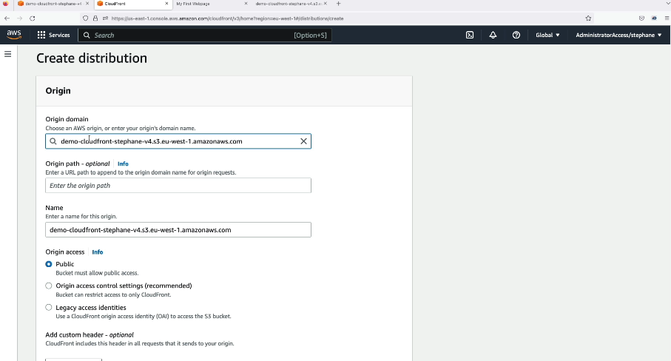

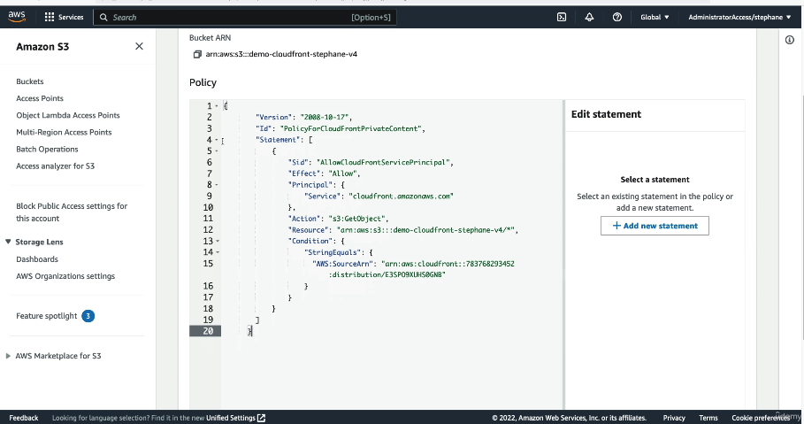

CloudFront with ALB (Application Load Balancer) as an Origin
When using Amazon CloudFront with an Application Load Balancer (ALB) as the origin, CloudFront distributes incoming traffic to ALB, which then routes it to backend EC2 instances. This setup helps in improving performance, security, and availability.

🔹 Why Use ALB as an Origin in CloudFront?
- Better Caching & Performance - CloudFront caches responses from ALB to reduce load on backend servers.
- Lower Latency - CloudFront delivers content from edge locations closer to users.
- DDoS Protection - CloudFront integrates with AWS Shield for security.
- HTTPS Offloading - CloudFront can handle SSL/TLS encryption, reducing the workload on ALB.
- Scalability - ALB automatically distributes traffic to multiple EC2 instances.

🔹 How It Works?
- User Requests Content:
  - A user requests a webpage or API hosted behind ALB using CloudFront’s domain name.
- CloudFront Checks Cache:
  - If the requested content is in cache, CloudFront serves it directly.
  - If not, CloudFront forwards the request to ALB.
- ALB Routes Traffic to EC2 Instances:
  - ALB sends the request to the appropriate backend EC2 instance based on load balancing rules.
- Response Sent Back to CloudFront & Cached:
  - CloudFront caches the response for future requests, reducing load on ALB.
- User Receives the Content Faster:
  - CloudFront serves subsequent requests directly from its cache.

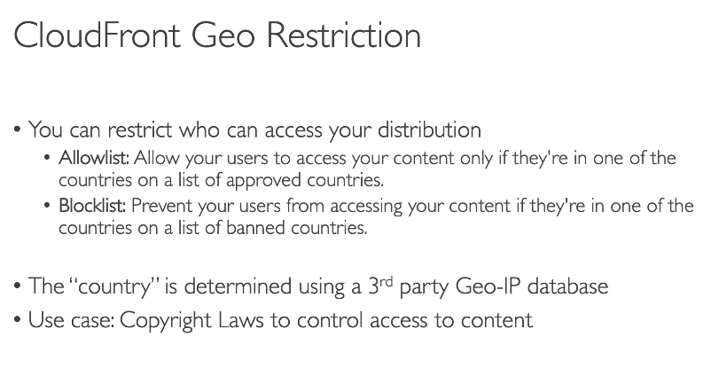
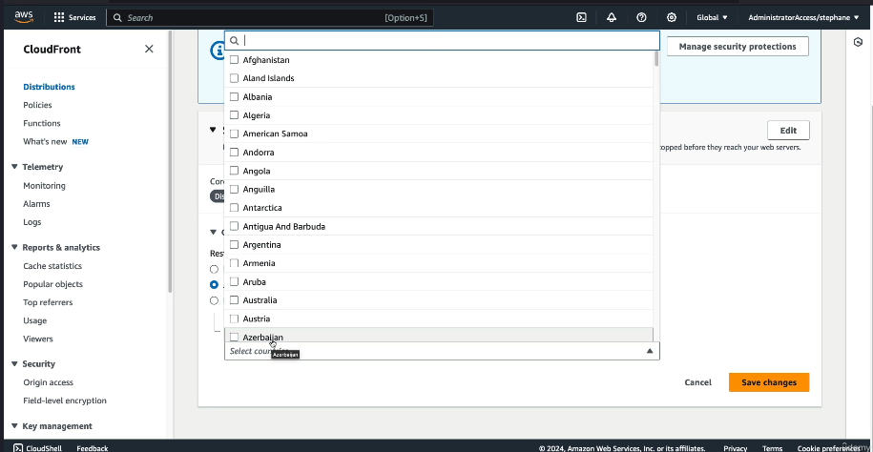

CloudFront Reports, Logs, and Troubleshooting
Amazon CloudFront provides multiple logging and monitoring options to track performance, security, and errors. These logs and reports help troubleshoot issues and optimize content delivery.

🔹 CloudFront Reports
CloudFront generates reports to help analyze request patterns, optimize caching, and monitor security.
1️Cache Statistics Reports
📌 Shows: Cache hit and miss ratio.
📌 Use Case: Helps determine if CloudFront is serving cached content effectively or forwarding too many requests to the origin.
2 Popular Objects Report
📌 Shows: The most frequently requested objects.
📌 Use Case: Identifies the most accessed content to optimize caching and reduce latency.
3️Usage Reports
📌 Shows: Data transfer, request counts, and top requesting countries.
📌 Use Case: Helps analyze traffic distribution and potential cost-saving optimizations.
4️Viewer Reports
📌 Shows: Viewer devices, operating systems, and browsers.
📌 Use Case: Useful for ensuring compatibility and optimizing performance for specific platforms.
5️Security Reports
📌 Shows: Traffic patterns, blocked requests (with AWS WAF), and threat intelligence data.
📌 Use Case: Detects suspicious activities or potential DDoS attacks
🔹 CloudFront Logs
CloudFront logs help in deeper analysis of request and response details.
1️Standard Logs (Access Logs)
📌 Where? Stored in an Amazon S3 bucket.
📌 What’s Included?
- Request URL
- HTTP status code
- Edge location serving the request
- User-agent details
📌 Use Case: Helps debug errors, analyse traffic, and detect suspicious activities.
2️Real-Time Logs
📌 What’s Included?
- Edge location details
- Request and response status codes
- Latency metrics
📌 Use Case: Immediate visibility into request patterns and troubleshooting latency issues.
🔹 How to Enable Logging?
- Go to AWS Console → CloudFront → Distribution → Enable Logging → Specify S3 Bucket.

🔹 CloudFront Troubleshooting
When CloudFront is not working as expected, common issues include misconfigurations, latency, caching problems, or incorrect origin settings.
1️High Latency Issues
✅ Check Edge Location Performance: Use CloudFront’s Cache Hit Ratio reports.
✅ Optimize Caching: Set proper TTL (Time-to-Live) values to reduce repeated origin requests.
✅ Enable HTTP/2 and Gzip Compression: To speed up content delivery.
2️Content Not Updating (Cache Issues)
✅ Invalidate Cache:
- Go to CloudFront → Invalidations → Create Invalidation
- Add object paths (e.g., /index.html) to force CloudFront to fetch new content.
✅ Use Versioning: Rename files (e.g., style-v2.css) instead of using the same file name.
3️403 Forbidden Error
✅ Possible Causes:
- Incorrect bucket policy for S3 origin.
- Origin access is restricted.
✅ Fix: Update the S3 bucket policy to allow CloudFront access.
4️502 Bad Gateway / 504 Gateway Timeout
✅ Possible Causes:
- Origin server is down or taking too long to respond.
✅ Fix:
- Check the origin health in CloudFront Monitoring → Origin Health Dashboard.
- Increase origin timeout settings in CloudFront.

5️Custom SSL Issues
✅ Check SSL Certificate:
- Verify if the certificate is correctly imported into AWS Certificate Manager (ACM).
- Ensure HTTPS is enabled in CloudFront settings.

✅ Summary
- Reports: Monitor caching efficiency, usage patterns, and security.
- Logs: Track user requests and diagnose errors.
- Troubleshooting: Resolve issues like high latency, 403/502 errors, and caching problems.
Would you like a step-by-step guide on enabling logs or troubleshooting a specific issue? 🚀

CloudFront Caching
Amazon CloudFront caching improves performance, reduces latency, and minimizes requests to the origin by serving content from edge locations instead of the original server. Proper caching reduces costs and speeds up content delivery.

🔹 How CloudFront Caching Works?
1️User Requests Content: A user requests an object (e.g., index.html).
2️CloudFront Checks Cache: If the object is cached in the nearest edge location, CloudFront serves it directly.
3️Cache Miss: If the object is not cached, CloudFront retrieves it from the origin (S3, EC2, ALB, etc.) and caches it for future requests.
4️Subsequent Requests: The next user gets the cached version, reducing latency and offloading traffic from the origin.

🔹 CloudFront Caching Controls
1️Time-to-Live (TTL) Settings
Defines how long an object stays in cache before CloudFront fetches a fresh copy.
- Minimum TTL (default: 0 seconds) – Forces CloudFront to check with the origin frequently.
- Maximum TTL (default: 31536000 seconds or 1 year) – Keeps objects cached longer.
- Default TTL – Applies to objects without explicit cache settings.
📌 Example Scenario:
If a webpage updates daily, setting a TTL of 86400 seconds (24 hours) ensures users get fresh content daily while reducing unnecessary origin requests.

2️Cache Invalidation (Force Refresh Content)
When content updates before the TTL expires, CloudFront can be forced to fetch a new version.
✅ Steps to Invalidate Cache:
1️Go to AWS Console → CloudFront → Distribution → Invalidations
2️Create Invalidation and enter file paths (e.g., /index.html or /* to clear all cached files).
3️Click Invalidate to force CloudFront to fetch fresh content from the origin.
📌 Use Case: When updating a JavaScript file (app.js), you may need to invalidate it to ensure users get the latest version.

3️Object Versioning (Cache Busting)
Instead of invalidating cache manually, use versioning to load updated files without needing invalidation.
✅ Example:
❌ Old file URL: https://cdn.example.com/style.css (Might serve old cached content)
✅ Versioned file URL: https://cdn.example.com/style-v2.css (Forces CloudFront to fetch the new version)
📌 Best Practice: Always use versioned URLs for assets like JavaScript and CSS files to avoid stale content issues.

4️ Cache Behavior Settings
CloudFront allows customizing caching per content type.
✅ Steps to Adjust Cache Behavior:
1️Go to AWS Console → CloudFront → Distribution → Behaviors
2️Select the path pattern (e.g., *.jpg for images, *.html for webpages).
3️Choose Caching Policy:
- Caching Optimized: Longer TTL (ideal for images, videos).
- Minimum Caching: Short TTL (for frequently changing content).
- Custom Policy: Set your own TTL values.
📌 Use Case:
- Images and videos should have long TTLs for better performance.
- Dynamic HTML files should have shorter TTLs to reflect updates quickly.

